Hancock MLC Test on Elekta

# Purpose

This procedure has two parts. Part 1 describes the QA patients used for the Hancock MLC test. Part 2 lists the steps taken to perform this test.

# Hancock MLC QA Patients

The MOSAIQ patients used for the Hancock MLC test are ZZZ_ELEKTA1_QA, ELEKTA1 for Elekta-1, and ZZZ_ELEKTA2_QA, ELEKTA2 for Elekta-2. The treatment course used for Hancock MLC is course 1. The name of each field is the instrumentation that the field tests: MLC or JAW. The ID of each field is made up of the gantry angle, an *M* for MLC or a *J* for JAW, and a 1 for upper or a 2 for lower. For example, the highlighted field in the below photo tests the upper jaw at gantry 270.

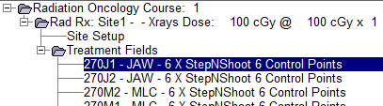

For the Hancock MLC test, you will only need to shoot the MLC fields, not the JAW fields.

# Hancock MLC Test Procedure

1. Set up linac.
   1. Remove couch top.

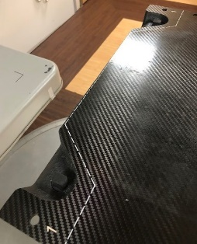

* 1. Use the control panel to set couch to 0. (The ASU buttons will only adjust the couch if it is within ~2 mm of its correct position.)
  2. Use the teal scroll bar on the linac hand pendant to set the gantry to 180°.
  3. Use the left gray button on the iView hand pendant to fully extend the MV imaging panel.
  4. Use the yellow button and the button directly below it to position the MV imaging panel according to the below photo.

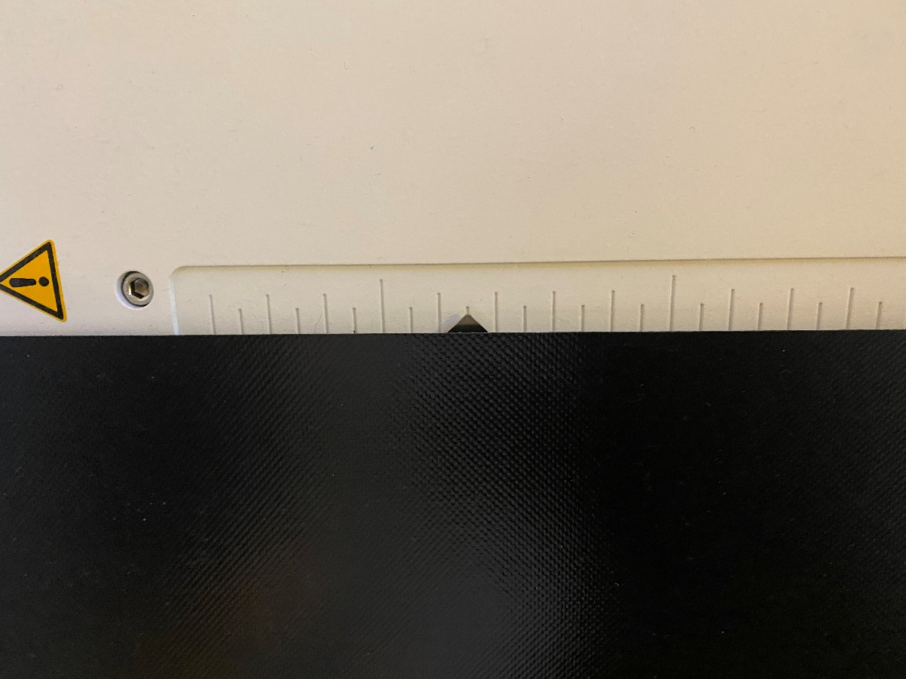

1. Open the patient in MOSAIQ (see Part 1).
2. Open QA Mode.
   1. Go to RO Treat.
   2. Click *QA Mode*.
   3. Click *Yes*.
3. Mode up first beam.
   1. Highlight the first MLC beam and click *Select*.
   2. Click *Close*.
   3. Wait until the only red fields are Gantry and/or Coll Angle. Use the ASU button on the linac console to correct the Gantry and/or Coll Angle.
4. Open iView.
   1. Double-click iView icon on Desktop.
   2. Log in to Clinical Mode using username and password *iview*.
5. Prepare iView to acquire images.
   1. Click the New Patient icon to create a new patient with name according to step (2).
   2. Select Site1. There is no need to select individual fields.
   3. Click the iCom icon. Note that step (4) must be complete in order for this to work!
6. Deliver beams.
   1. The moded beam will automatically load in iView. When iView says “Ready to acquire…” and top strip in bottom left corner of linac computer says “Ready to Treat,” press the green MV button on the linac console to deliver beam.
   2. When the beam finished, click *Record* in MOSAIQ.
   3. Repeat steps (4) and (7b) for the remaining MLC beams. Do not close iView until all beams have been recorded.
7. Click *Done* icon in iView.
8. Analyze images using SNC Routine.